Bec Penglase – Australian volunteer profile - Solomon Islands
I arrived in Auki, Malaita Province, at the beginning of May this year. My volunteer assignment is with the Malaita Provincial Government as a Human Resources (HR) Mentor for six months. This is my first formal volunteering experience.

The Malaita Government introduced HR Management function this year, and is the first Provincial Government to do so. My counterpart, the HR Manager, Richard Misi, was recruited to the role in February. Our bold vision is for “a new strategic start for the Malaita Provincial Government”. Richard and I both share the same passion for improving the lives of employees by increasing morale and capability. Although we are a new team, we are proud of what we have achieved together and can see we have started the momentum for change.

When I arrived, I was expecting to ease into the working environment, but by day two I was conducting interviews for Malaita’s new Community Liaison Officer pilot program, funded by the World Bank. Despite first-day nerves, interviewing candidates was an amazing experience. Travelling an epic 36-hours by boat to Malaita Outer Islands to conduct some of the interviews was both a mental and physical challenge. However, the people of Ontong Java Atolls amazed and inspired me with their passion for their communities and their ambition for the new role.

One of Richard’s key goals is to create a sense of belonging with all staff. No matter your position or location, we are all “one team”. Richard and I have visited multiple government sub-stations to gather employee feedback and form stronger connections between sub-stations and Head Office. We have also held a workshop with Heads of Divisions to discuss their ideas for how to overcome challenges. These are just some of the activities we are doing here, and an integral step towards achieving the goal of one team and our broader HR vision.

Over the next two months we will be facilitating workshops to co-design the leadership roles and responsibilities, performance management process and refresh the staff instructions manual. The workshops aim to empower employees by clarifying their roles, strengthen the leadership team and give them ownership of workplace processes by involving them in the design phase.

Outside of work, I am loving the slower pace and simple life in Auki. It reminds me of growing up in a small country town in Australia and is a nice change from the hustle and bustle of city living. Auki has also given me the opportunity to get creative with my cooking and enjoy the process from beginning to end. I’m splitting coconuts using stones, scraping them out on the balcony while taking in the stunning sea and mountain views. I’m making sauces, tortillas and cakes from scratch. I’m learning the local cooking methods, and now teaching others my style of cooking.

The most rewarding part of volunteering in the provincial areas is the opportunity to integrate and be part of the community. I have become part of Richard’s family, with his three kids now calling me “Aunty Bec”. When I walk to the shops or market, I’ll bump into locals I know and ‘stori’ with them. It feels just like home. It’s going to be sad to leave Malaita - it’s a very special place, but I know I have ‘staka’: fond memories and stories to take with me.

Bec’s assignment is funded by the Australian Government through the Australian Volunteers Program managed in Solomon Islands by AVI. Each year up to 46 new volunteers arrive in Solomon Islands to take up their assignments in various sectors as part of the program.
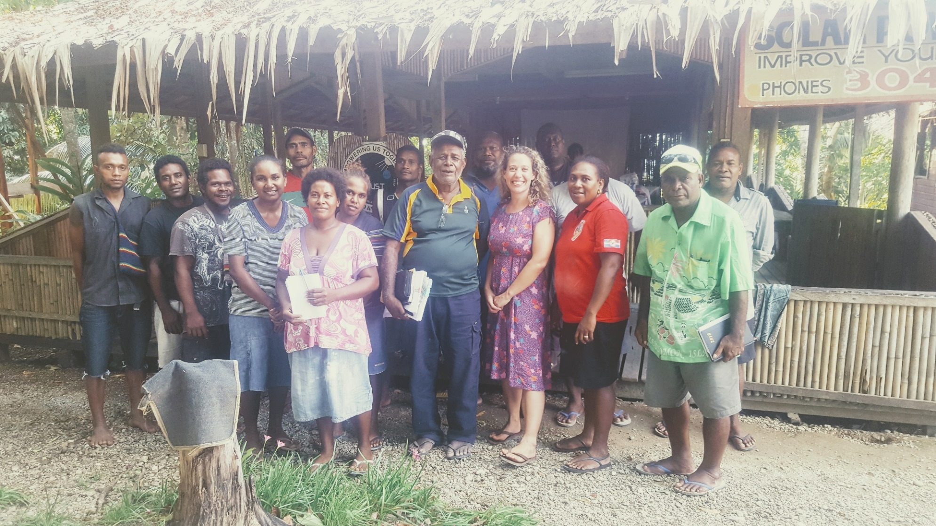
"Visiting our provincial government staff based at the Malu'u substation".
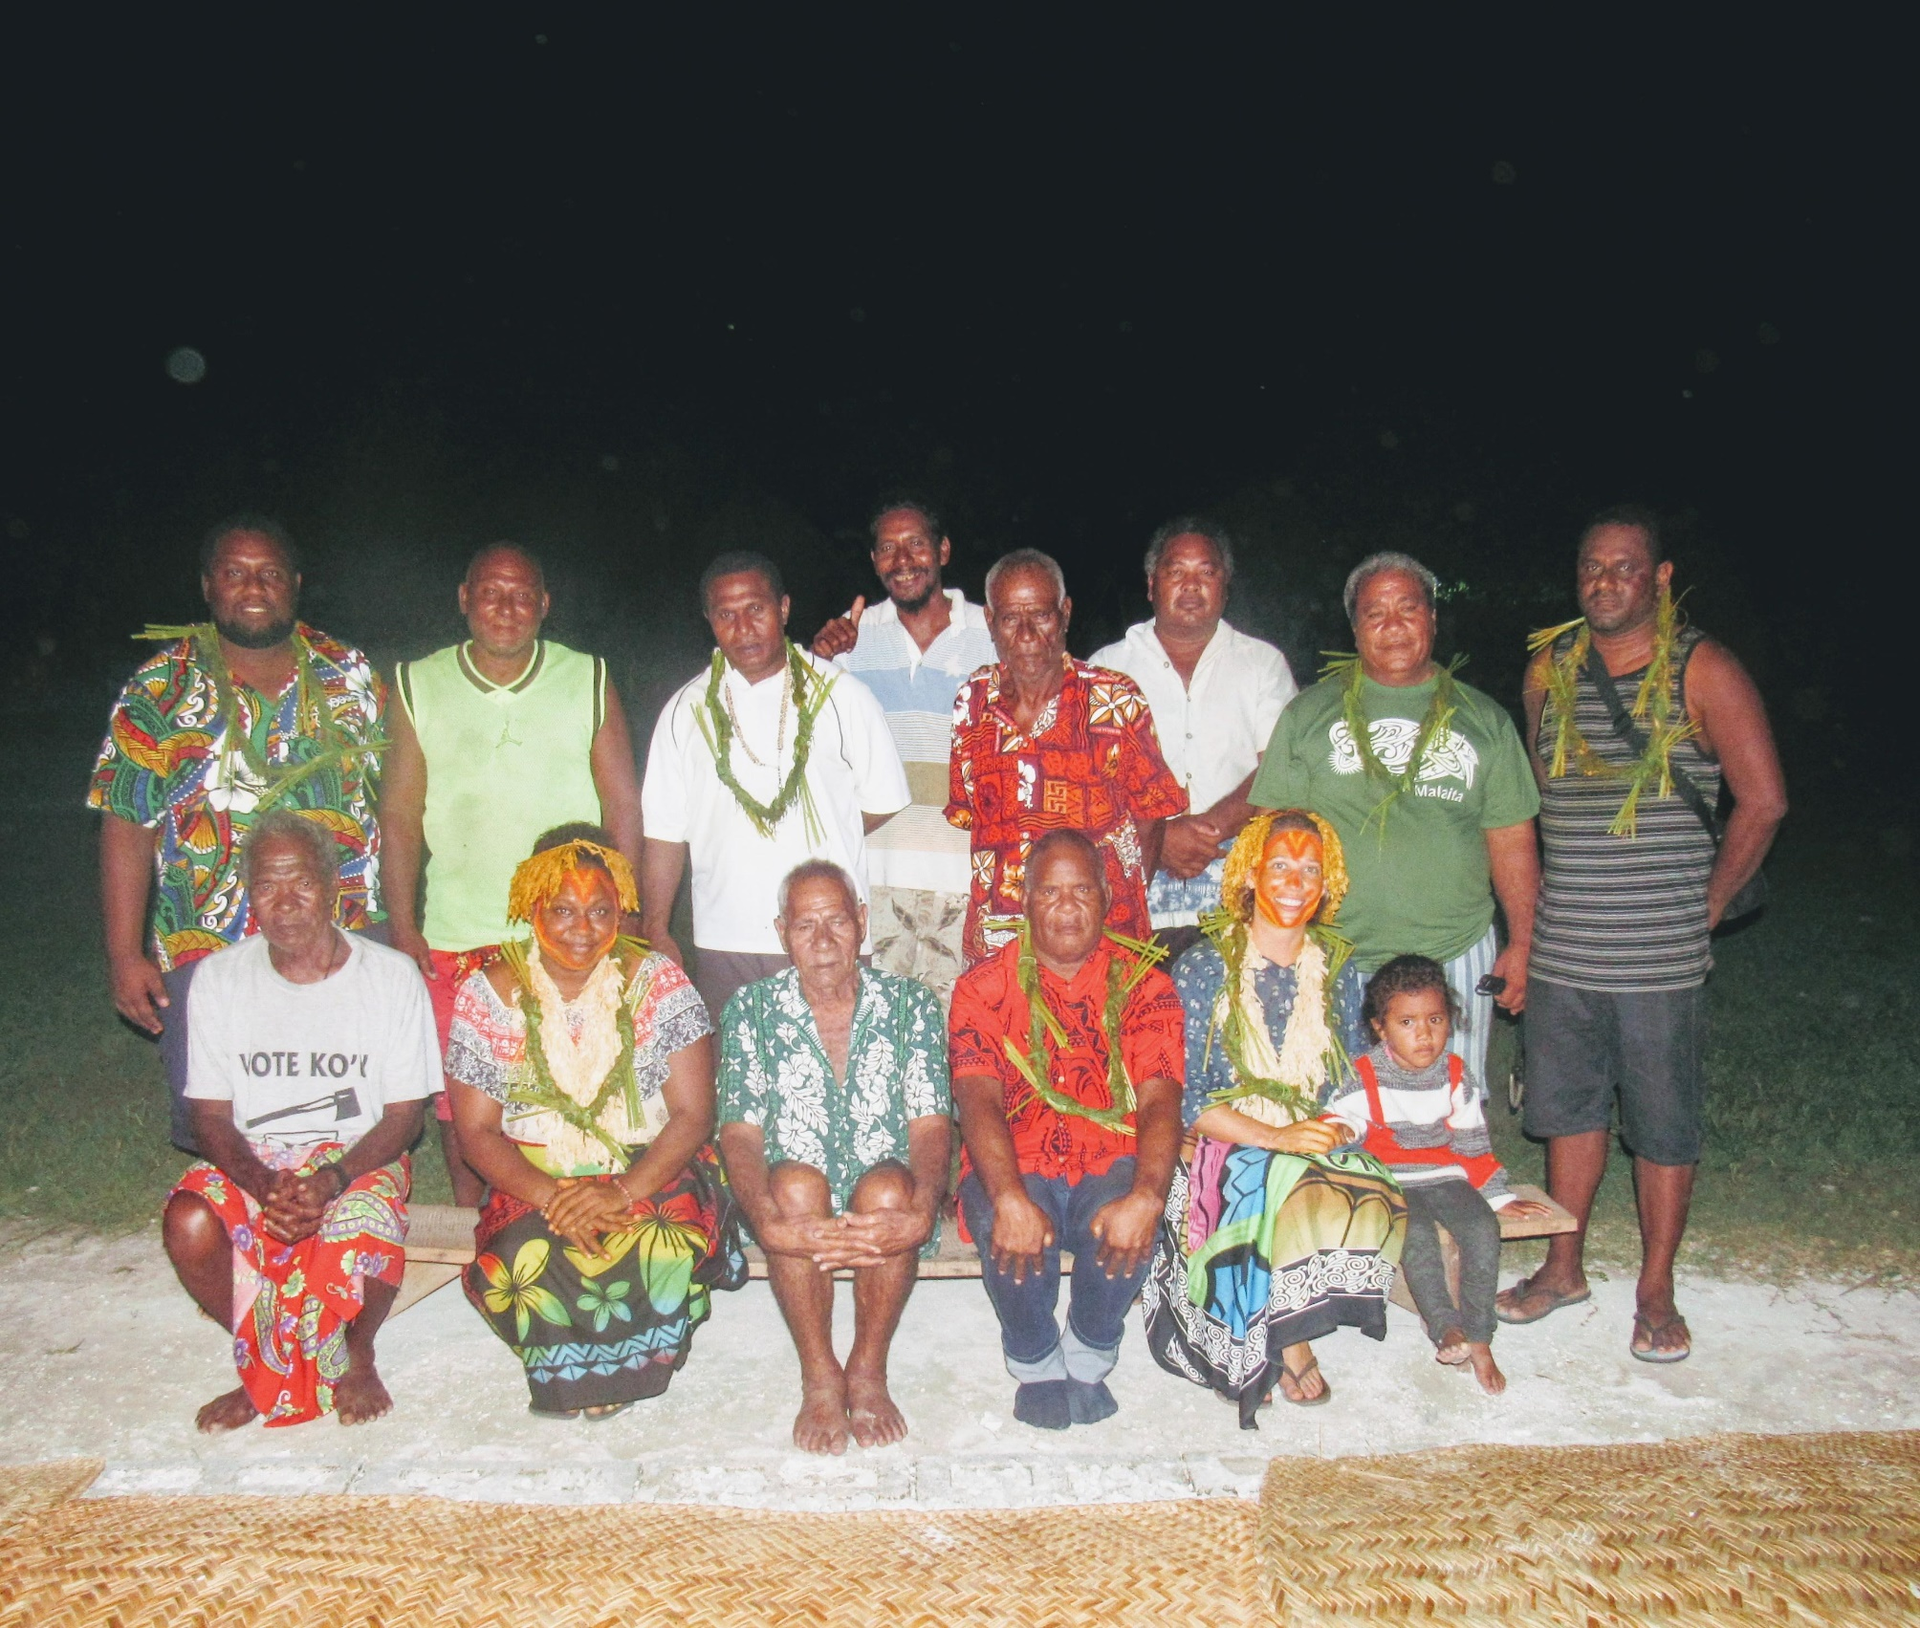
The Pelau community (Ontong Java Atolls) prepared a farewell dinner for us, including local dancing. This photo is of the team I travelled with, the local Chief and Elders"

